**Task 2 – Designing a website to meet client requirements**

**Mohammed Mahin Ibnay Mamun / 346584**

**Unit 15 – Website Development**

|  |  |
| --- | --- |
| Unit/Criteria reference | To achieve the criteria, you must show that you are able to: |
| P2 | Produce designs for a website that meets client requirements. |
| P3 | Review the website design proposals with others to identify and inform improvements. |
| M2 | Justify the design decisions, explaining how they will meet the user's needs and be fit for purpose. |
| D2 | Evaluate the design against client requirements. |

**Website design:**

As soon as you get hold of the concepts behind a reliable website design, by creating your own website, you will be able to put them into practice. It is also important not to skip any of the steps in the website design process, if they are skipped, there will be major problems.

**Problem Definition:**

For web developers, it is essential to gather as much information about the website's requirements from the client as possible before creating the website. To do an effective job of fulfilling a client's requirements, a website developer needs to understand the requirements as much as possible.

**Intended Audience:**

You should always keep the needs of both users and clients in mind when designing a website, since they are your intended audience, this is understandable.

Often, the client is the individual who has authorized the website and has also agreed to pay the bill. Clients may not pay you, as the website developer, if they are not pleased with the website you created.

Visitors to the site are called users. Your intended audience is also them. To increase conversion, the website must first attract users and encourage them to return repeatedly to make sales.

My intended audience will range from ages 18+.I chose an older target audience because the audience will also be both male and female, this is because my products are for both genders.

**Understanding the problem/requirements:**

Developers must communicate with clients to have a full understanding of the problem they are trying to solve. The process of gathering requirements can be done in a variety of ways. The most common method is SQIRO. To create a website that is intended to solve a client's problem, a website developer will employ these techniques to collect as much information as possible to fully comprehend the situation.

**Money/budget:**

When starting up my own website, I will need to keep a budget. Here are a few reasons why I need to have a budget.

* Know where my money is going.
* Prepared for emergency.
* Allows you to save a lot of money.
* Better debt management.

When creating your own website, you will need some sort of money to start up with. The first thing I would do is buy a domain with the money. This allows me to get a personal link which can be shared to redirect others to me.

Another area where I would use the money is advertising. For example, I can use SEM (Search Engine marketing).

**Timescales:**

To organize this activity, the organization needs to develop a timescale through an action plan to coordinate the content posted on the various platforms. If the organization has more than one employee, such a plan would let you know when a certain employee should add products or information to the website. It will still be useful to you if you are operating on your own. My businesses will display the action plan as a timetable. A timetable is the fastest way to understand the action plan.

**Staff Training:**

The purpose of staff training is to prepare specific staff members for their position by providing them with the knowledge and skills needed to perform their duties. When preparing inexperienced staff members for their role, it is often mandatory to offer them some level of training. When I build my own website, I will need staff to support my site when I am unavailable. To ensure that my staff understands how to manage my site, I will need to train them ahead of time. Site updates and maintenance could be among the staff duties. Information could be added, removed, and products could be added.

**Security:**

No one wants their website to be hacked, therefore security is essential. In website security, any action or application taken to prevent cybercriminals from accessing website data or to keep websites from being misused is considered security. It is most often malware that is responsible for cyberattacks, which is software designed for malicious purposes. Malware can do the following:

* You will lose your website's ranking in the search engines.
* Take credit card information or phone numbers from customers.
* Crash your website or cause it to slow down.

The following tools can help you to protect your website from dangerous cyberthreats:

* Protect your website against cybercriminals and malicious traffic with a web application firewall (WAF).
* Website scanning, by scanning your website, you can learn how vulnerable your site is and how you can protect it. This method is especially useful and effective for protecting your website.

Below are a few common website hacks:

* Website hackers use SQL Injection to hack websites in 2021 since most websites interact with their database using SQL.
* As another immensely fashionable way for hackers to attack a website, XSS (Cross Site Scripting) is also known as Cross Site Scripting.
* This technique, also known as Cross Site Request Forget, allows unauthorized actions to be performed through an authenticated user.
* Cookie theft
* DNS spoofing
* DOS & DDOS
* Phishing
* Social engineering
* Brute Force attack

**Benefits of a website:**

Clients approach a website developer to learn about the potential benefits of having a website. The advantages a website provides a business include:

**Advertisement:**

Web advertising differs from traditional television and radio advertising techniques, which target large segments of the market. Users can specify geographical location, age, gender, and interests of the target group before the advertisement appears. Advertising websites can be available worldwide.

**Cost:**

The cost of creating online advertisements may be lower than those appearing on TV, radio, and in print. In research, the average cost per thousand impressions of online advertising is between $3 and $10 and the average cost per click is between $1-3. cost per click (CPC) ranges from $1 to $2 on average. On the other hand, if you wanted to pay for a tv advertisement, a 30-second commercial, advertisers must pay a minimum of $5 per 1,000 viewers. However, this is quite outdated, and the cost now may be much higher.

**Accessibility:**

Websites can be accessed from anywhere in the world, which is one benefit of creating them. As a result of using this feature, businesses make more sales, so they are more successful. There is no benefit to having people from another country looking at your website unless your business accepts worldwide shipping.

**Popularity on the internet:**

Due to the growing popularity of the Internet, online shopping is being embraced by more people. Since computers have been widely spread and Internet use has advanced rapidly, the internet has offered consumers not only an array of information, but also a possibility to make purchases at home.

**Long-term clients:**

The obvious benefit of having a website is that it can help you gain long-term clients. For example, if I create a shoe store, it is likely that I will sell my products. If my products meet their needs, then they are likely to return to my store for more products. This is one way of gaining long-term clients.

Another way you can achieve this is by giving your clients deals or discounts.

**Interactivity:**

With a static website, you may lose customers. The level of interaction on the website should be decided in advance. The wrong amount of interaction can cause users to feel overwhelmed, while the wrong amount can lead them to feel uninterested.

**Ecommerce:**

E-commerce is when the internet is used for electronic commercial transactions. Ecommerce refers to every time someone or a business buy or sells something online. Ecommerce consists of business over the internet, goods or services can be bought and sold, as well as money transferred to complete the deal.

Here are some of the advantages of e-commerce:

* Cheaper cost
* Wider base of customers (worldwide)
* Open 24/7

**How will users browse the online catalogue?**

There are various categories of products on most online stores, where you can filter products. Relevance, time, and price are considered, as well as customer reviews. There are also more filters such as: most relevant, new release and sale. Users can find the perfect product for themselves by adjusting through these filters.

**How will users make purchases?**

Obtaining credit card information from the website is a prerequisite before the user can purchase an item. TLS (Transport Layer Security) is used to encrypt this information. This is commonly used by PayPal. Pay Pal uses this method since it stores all your financial information, including your credit card number. Paying for e-commerce is done through Stripe, Apple Pay and PayPal.

**Server-side and Client-side scripting:**

**Client side:**

* Frontend
* Collects the user's input
* User input and visual aspects are addressed
* scripts can be restricted to run in a sandbox

An operation on the client side of a computer network refers to an operation that is carried out by the client itself.

**Server side:**

* Backend
* Processes the input of the user
* Deals with transactions and computations
* Transparent processes to users

The source code of the scripts is hidden or not visible at the client side (browser) because server-side scripts are being used at the backend. An online server runs server-side scripts to create the page that a browser needs to display.

Purpose Requirements:

All the available information must be collected before requirements are developed. SMART means: Specific, measurable, achievable, realistic, and time bound. A SMART requirement consists of the following elements:

**Specific:** Focuses on a particular area for improvement. Specificity is important so that the designer and developer can comprehend the requirement.

**Measurable:** It is best to avoid any requirements that cannot be verified as being completed. You can measure whether the requirements have been completed.

**Achievable:** Attainable requirements. Will the team be able to achieve the overall goal? For whatever reason, the goal may not be feasible. It should be discussed.

**Realistic:** Based on the available resources, is it realistic to meet the requirement? Is it too much? Is it too little?

**Time:** Within the timeframe provided, the requirement can be accomplished. The team should be given plenty of time to complete requirements within a realistic timeframe, since there is a limit as to how quickly this can be done in a certain amount of time.

**Design ideas:**

As a result, by this point, you should have a good understanding of what the client wants the website to do. To achieve this, you can create a website that the client can review and approve using design tools.

A website can be developed from a design that has been approved and then put online. The principles of reliable website design should be incorporated into the creation of any website.

**Prototyping:**

Design teams prototype ideas from paper to digital forms to convert their ideas into tangible forms. You can refine and validate your designs with prototypes to allow your brand to release products it believes will be a success.

A prototype is not unusual for developers when creating any IT product, including websites. This allows users to see what the website will look like and what it can do. It is often built on an assembly line before the prototype is built to produce many copies. This idea originated in engineering.

**Mood board:**

In graphic design, a mood board refers to a collection of textures, images, and text used as a reference point for design ideas. Mood boards can also be referred to as a collection of images used to generate a final design. Below is an example of my mood board which I have created for my trainer website.

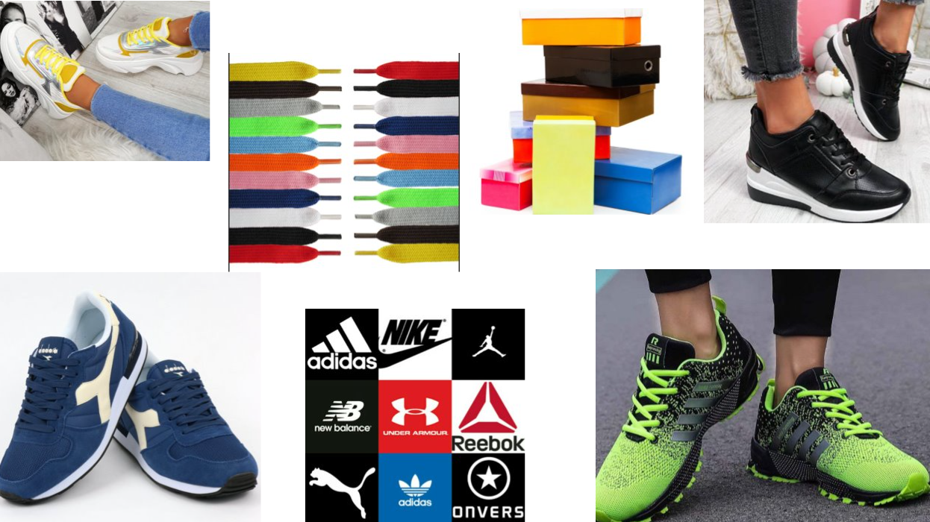

Even though this is not my final design, I have included a couple of images that I will refer to, to complete my final design.

Because my website will cover both men's and women's shoes, in addition, I used both men's and women's shoes since both genders will be covered on my website. Furthermore, I tried to figure out how I can create my logo by using a variety of brands and colors shoelaces and boxes depending on what I want to create.

**Wireframe:**

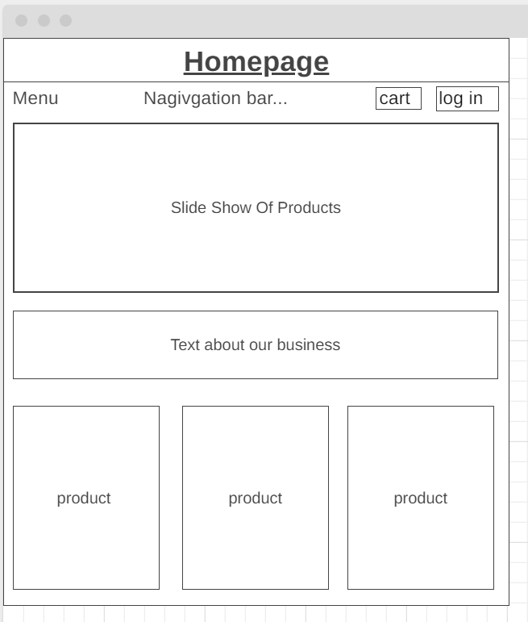

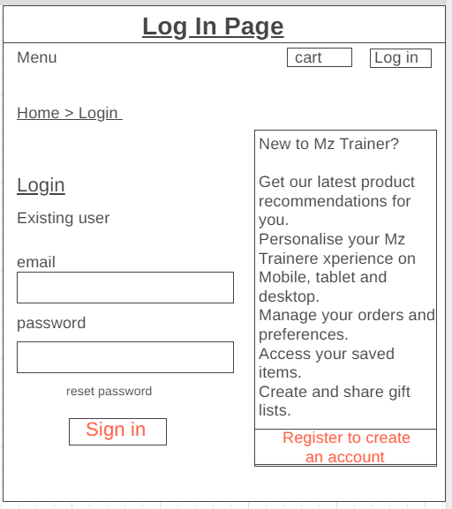

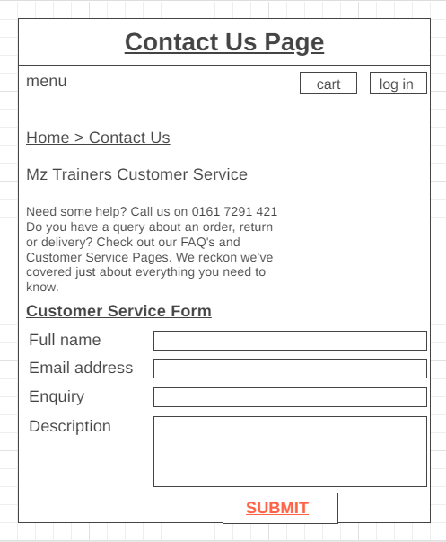

I have created 3 wire frames. The first wire frame which I made is the home page. This page will be navigatible and you will be able to see our products and some description of our company.

The second wireframe which I created is the login page. This page can be accessed from the homepage. When the customers click on the log in button, they should be redirected to a page which looks like this one. The user has the option to either log in or they can register for an account. Above the register for a new account button is a small description, this will consist of the benefits of creating an account. If the user has an account but has forgotten their account, then they can reset their password.

This final page which I have created is the contact us page which can also be accessed from the homepage. To get to this page, you simply need to scroll down to the bottom, and you will find a button which says contact us. On this page, the customers can send a message which will go back to the company. This is useful for any refunds.

**Sitemap:**

Users or crawlers can access site maps by clicking on hyperlinks. A website map can take any form, If the plan is a document, or if the page is a web page, it should be a document that assists in the design of the website. Moreover, it represents how the pages are related, representing the connections between them.

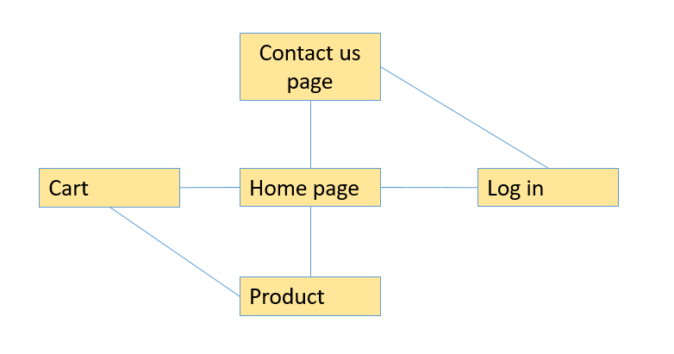

In my sitemap, you can see the homepage is in the center, this is because it is the main page. The homepage can lead you to all the other pages and from all pages you can get back to the homepage.

If you are on the cart page, then you can also get to the product page vice versa.

From the contact us page, the customer can access the login page vice versa.

**SMART Requirements:**

The website I plan to develop will be the website for a sneaker/trainer company, which will include products such as trainers, shoelaces, and crease protectors.

**SMART:**

* To search for specific products on the website, there needs to be a navigation bar at the top of the page
* Ideally, the site should have a home page, product page, and checkout page.
* Various payment methods should be available for each product.
* It is necessary for the website to include a menu to filter results by a field in the server's database.
* The space on the page should be equally distributed between the assorted products.

**Non-SMART:**

* One product should be available.
* The website should display products.
* You must be able to customize the website.
* Matching the logo to the website's color scheme.
* Several pages must be present on the website

**Implications of not using SMART requirements:**

There are drawbacks of having a specific product store.

1) one store product

* The pressure is enormous when you only have one product to sell. You are counting on that one product to be successful, which is quite a challenge.
* You will need to conduct a thorough market study before you start a one-product store.
* By cross-selling complementary products to your existing customer base, you cannot multiply your revenue when you only have one product.

2) no products on the webpage

* A lower click rates to your page.
* No product advertised.
* Lower conversions.

**Search Engine Optimization (SEO)**

If you want to maximize the number of users looking in this regard, it is imperative that the design conveys an effective solution that will keep users coming back to your website. You must design it in a way that makes users feel welcome. The benefits of having a traffic-generating website include higher rankings in search engine results pages, since users are more likely to click on the first link, they see in a search engine results page. It is not enough for a clever design to attract users to a website; a superior design may encourage return visits, even if a user finds the website.

**Alternative design ideas**

In case problems are found with the preferred design, alternative designs should be considered and thought through. In addition, clients should have more choices when it comes to the design.

Mood boards and storyboards present alternative design ideas. Once the client is happy with one of these designs, it is time to move on to designing the wireframe.

During the requirements stage, it is necessary to contemplate mobile devices' compatibility.

**Example of website compatibility on mobile:**

Business websites are increasingly mobile friendly these days. Mobile phones have become increasingly popular, which may have contributed to this trend. Users tend to open websites on their mobile devices to seek information. Compared to many years ago when people used computers and laptops, more people nowadays use smartphones and iPad.

You can maintain your website's mobile friendliness by following these suggestions:

* Begin with a mobile release.
* Transform a desktop site into a mobile site.
* Base your site theme in a responsive manner.
* Avoid using flash add on.
* Have a fast-optimizing site.
* Use images Aswell as standard easy to read fonts.

**Client-side scripting design**

When a user visits a website on their browser, client-side scripts run on their computer. In addition to interactive features, client-side scripting can be used to implement animations and integrate media elements into webpages. A website's scripts are written in JavaScript, a programming language designed to run inside a web browser.

After the design and layout of a website have been completed, the script is written. This way, when the scripts are created, the developers will know exactly what the website's function is. Documents such as wireframes and pseudocodes can also support this claim.

**Methods for developing a website**

**Flowcharts:**

It is important to understand how a website should work and to get an idea with the use of flowcharts when designing a website. A flowchart is a diagram that shows how a system functions, its algorithms, its processes, etc.

A flowchart follows a pattern for how it should be presented, it has symbols representing how each symbol relates to one another through arrows.

I can use flowcharts to visualize

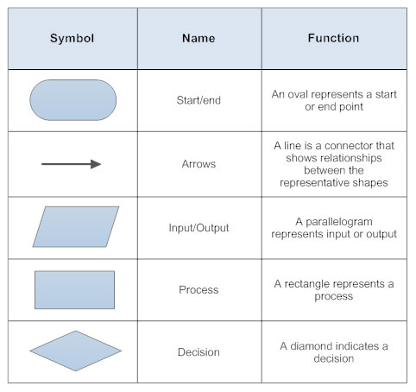

**Pseudocode:**

In the same way as flowcharts, pseudocode provides a visual representation of system functionality, but unlike visual methods, it is created once the design has been completed. A pseudocode is a programming language that combines the language of English with the language of code but does not follow any language conventions.

This is a set of rules that are governed by programming languages, such as if statements or variables. Using pseudocode makes it possible to translate it easily into any programming language. It is not necessary to worry about syntax errors or any specific language features when writing pseudocode for a program, since it may be easily understood and written.

As an example, here is a pseudocode example I would incorporate into my website; In systems such as the form validation on the contact us page, I can convert pseudocode into actual code using pseudocode when developing the website.

**Examples of Pseudocode:**

|  |  |
| --- | --- |
| **Pseudocode** | **JavaScript** |
| OUTPUT “Hello world” | { document.write ("Hello World") ; } |
| If age>= 18 THEN | If (age>=18) |
| Name = USERINPUT | name=prompt ("Enter name", "") ; |
| ELSE | Else |

**Gathering feedback from users/clients**

In the process of designing a website, it is important to gather other people's feedback. This will allow you to determine whether the design meets the requirements and if any changes can be made to improve it. As a result, you can determine whether accessibility and usability could be enhanced.

It is an essential part of the design and development process because if issues are discovered with the design after the developer begins building the website, it will prevent it from going live on time. Additionally, there is a possibility that the website may not be as good as it could have been due to time and cost.

One big reason we are gathering feedback is, so we do not need to readjust after the site is available. Suppose I was to code a website, and then I received a recommendation before completing it, I could understand it easily and add it to the code. This would appear unprofessional if the site were simply uploaded and then taken down for further adjustments.

**Methods for obtaining feedback:**

To obtain feedback, questionnaires can be used. Questionnaires can be used to gather feedback, identify strengths and weaknesses, and identify areas for improvement. Qualitative and quantitative questionnaires can be distinguished as different methods of questionnaires. Additionally, we can conduct interviews or a much simpler survey.

**Quantitative questioning:**

To gather feedback on the website, quantitative questions would be used. To see whether users were happy with the website, the main respondents to the quantitative questionnaire would be the users and the testers. The information can be used to determine how an average user will view a site and to determine areas for improvement.

By asking quantitative questions, you can receive general feedback about your website. Use quantitative questions to get a broad understanding of how someone sees your website. The questionnaire taker acts as the respondent by checking a box to see if they agree or disagree with each statement. However, a number scale can also be used for statements or for the part of the website that they found decent.

**Qualitative questioning:**

Quantitative questioning tends to provide very general feedback to the website, whereas qualitative questioning provides much more detailed feedback. Rather than agreeing or disagreeing with statements, questionnaire respondents are asked to write down their opinions on the website and respond to questions in text. There can be no averages compiled if qualitative questions are analyzed and cannot be bundled into one. Qualitative questions are a minority in all the responses.

When seeking feedback on the website from the client's team/client, as well as certain users, we will use qualitative questioning techniques as part of the qualitative questioning process, we will ask both the client's team, as well as specific users for feedback on the website. Using qualitative questioning, however, cannot accomplish this, as the questionnaire taker does not have the option to provide their own opinion.

**Designing and gathering feedback for the website**

**Analyzing alternative design ideas:**

**Homepage:**

There are 3 columns of products and two rows on the homepage content of the website homepage, but there could be improvements in how white space is utilized and how the layout is structured. There is limited white space between the boxes on the website. To improve this, we could fill up the white spaces with the background color or even the brand logo.

To make the box of products more manageable, we leave white space between them. Furthermore, the website will be more accessible, as people with visual impairments can read larger texts better than smaller ones.

**Products page:**

In addition, when the text on the website is larger rather than smaller, the website will be more accessible, since people with visual impairments are able to read it better. This can become confusing for the user if he or she clicks the load button multiple times. It would be impossible to track on which listing each listing is located. A page system can be added if the page becomes too long.

**Account/Basket page:**

I will have a basket page on my website that lets you see the items you have added to your basket in addition to letting you remove them. On the basket page, you will find a button that lets you purchase the items in your basket.

If a customer wants, she or he can input their mobile number and billing address on the account page. When adding information, it asks for the customer's first and last name as well as their email address. The website's company will not ask for your confidential information for safety reasons and only you (the customer) can see this page.

**Contact us page web form**:

At the bottom of the website's contact us page, you will find a form that can be used to contact us with any support or questions.

**(Flowchart)**

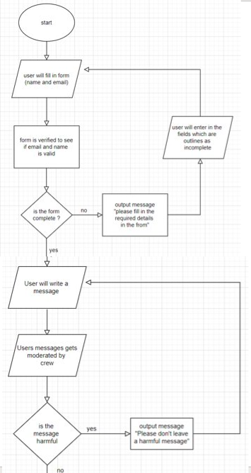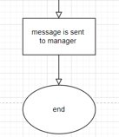

In the flowchart above, the user who is the customer is asked to provide their name and email address first. Then I will get the website to check for the following account to see if it already exists. If not, a message will appear on the screen that asks the user to enter their information again. As soon as this stage is complete, the user will be able to write a message, which will then be moderated by a company representative to ensure it is user-friendly. If the user cannot rewrite the message, he or she will have another chance to do so. Should the message be user-friendly, it will be delivered to the manager or employee.

**Questionnaire:**

The questionnaire will consist of both quantitative and qualitative questions. There will be a quantitative questionnaire on the website, comprising of 10 statements, each of which can be answered from 1 - 10. 1 is a negative answer and 10 is a positive response.

Alternatively, the questionnaire will ask clients and users what their opinion is about the website for qualitative questioning.

**Quantitative Questionnaire Responses**

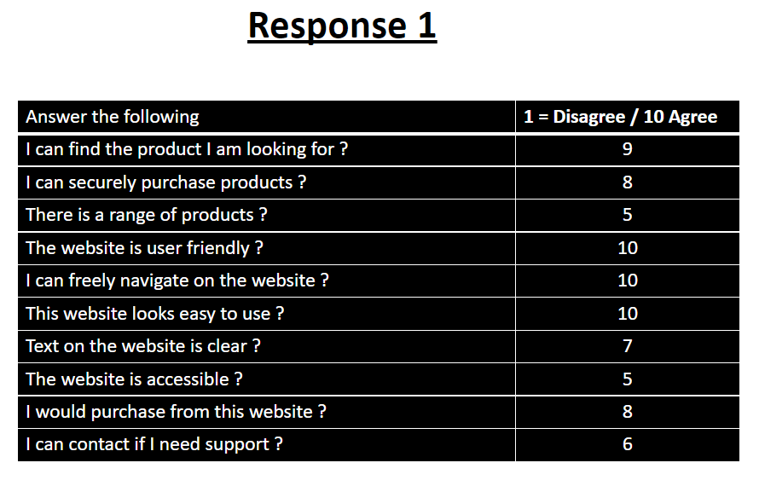

1) Looking at the results above, we can clearly see that our first user has been quite positive about our website. From the results we can see that they totally agree with the idea that our website is: easy to navigate, user friendly, and looks easy to use. It was unclear whether they agreed or disagreed that the website has a range of products and that it is accessible.

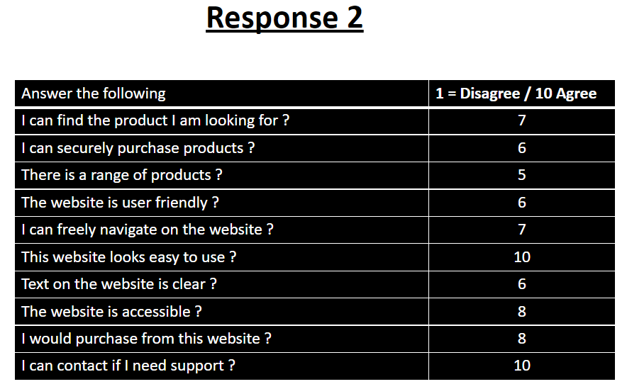

2) Another user responded positively. They agreed with all the statements. However, they strongly agreed with two points: they would understand how to contact support, and the website is easy to navigate.

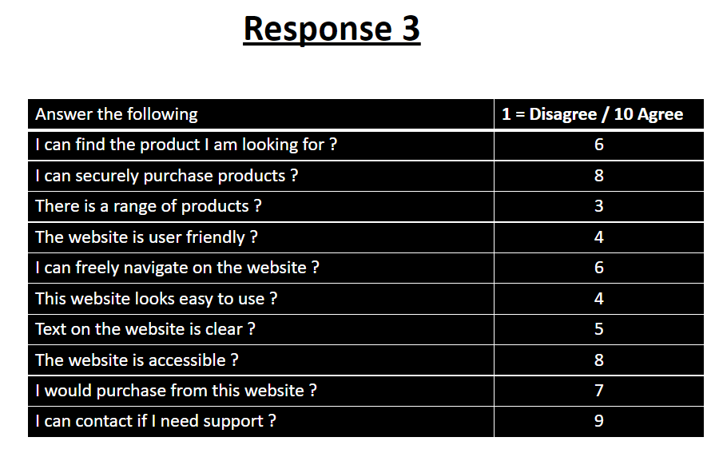

3) The responses from this user were quite balanced. There were areas where they agreed and areas where they disagreed. As an overall result there were not any totally agree and not totally disagree either.

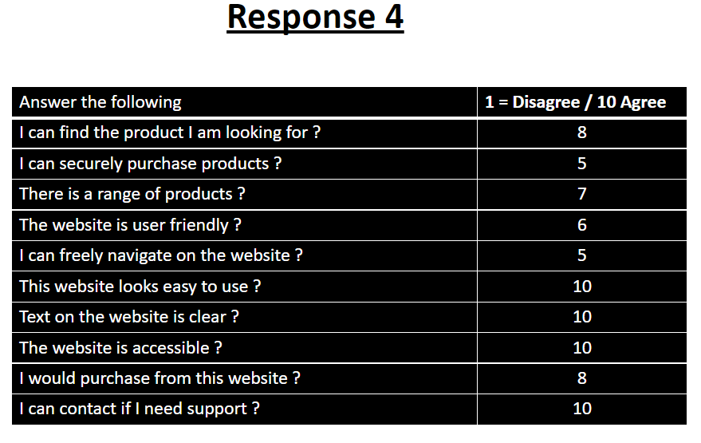

4) This reviewer's response was the majority totally agreed. There were only 2 statements which were balanced which were: the website is navigatible and they can securely purchase products. The rest of the reviews were more in agreement.

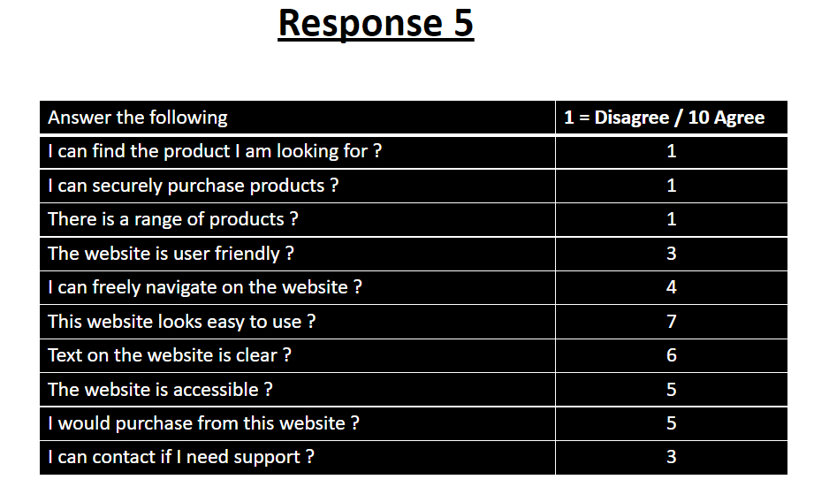

5) This individual gave most of the replies that we received negative responses. This user totally disagreed with the first three statements. Overall, they were not dedicated supporters.

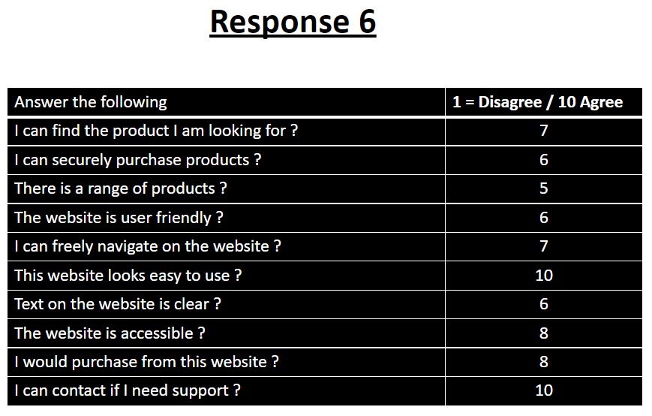

6) As we can see from the questionnaire, this reviewer gave us quite a positive response overall. They totally agreed with 2 of the statements which were provided. Only one of their responses was balanced at 5 and the rest were in between.

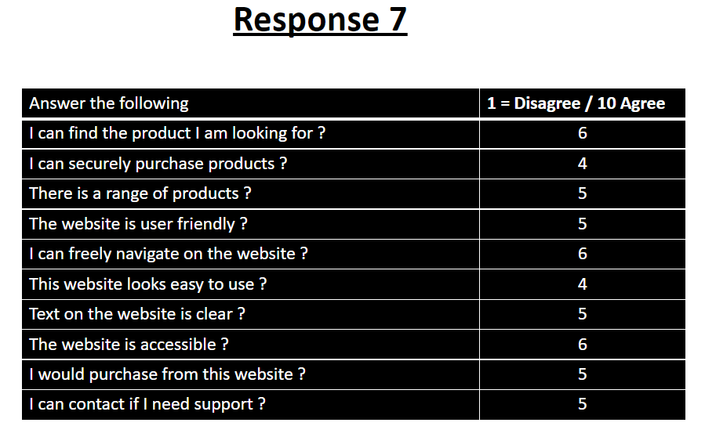

7) From this user, there was a range of answers from 4 – 6 meaning they were quite balanced. This review is like one of the other users from earlier. They did not totally agree, nor did they disagree.

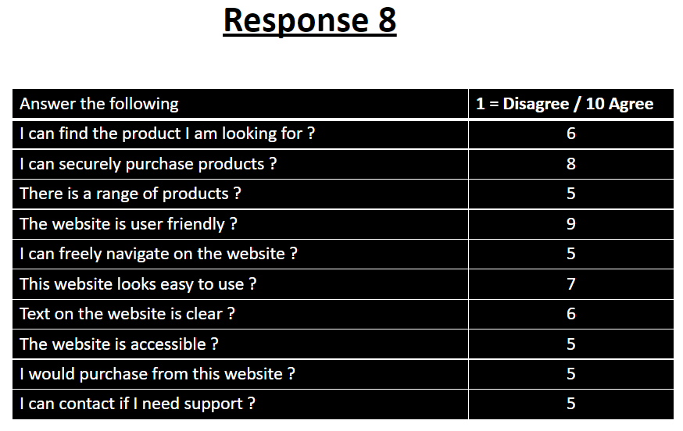

8) From the eighth responder, we had quite a balanced but also a positive overall response. A few of the responses came with a 5 meaning it was balanced between both agree and disagree. Whereas the rest remained over 5 showing they were more positive and more in agreement.

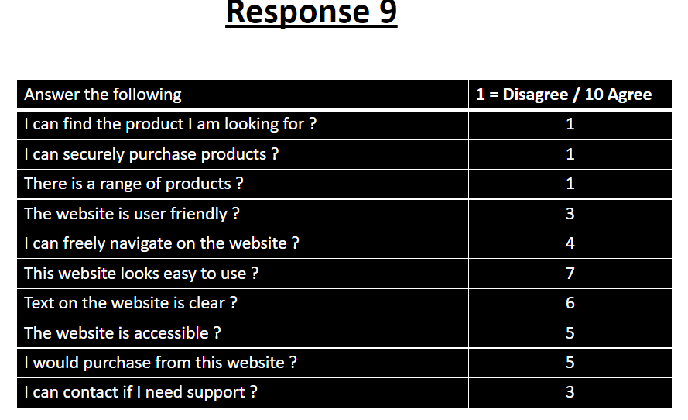

9) From this individual, most of the responses which we received were negative. This user totally disagreed with the first 3 statements. Overall, unfortunately they did not strongly agree.

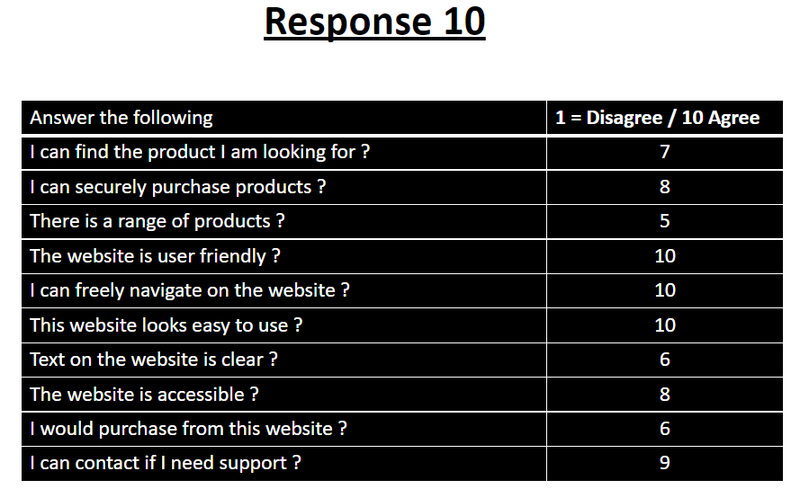

Here is a more agreeable response. The questionnaire received 3 total agreement responses and a low response at 5. There was no disagreement.

**Qualitative Questionnaire Responses:**

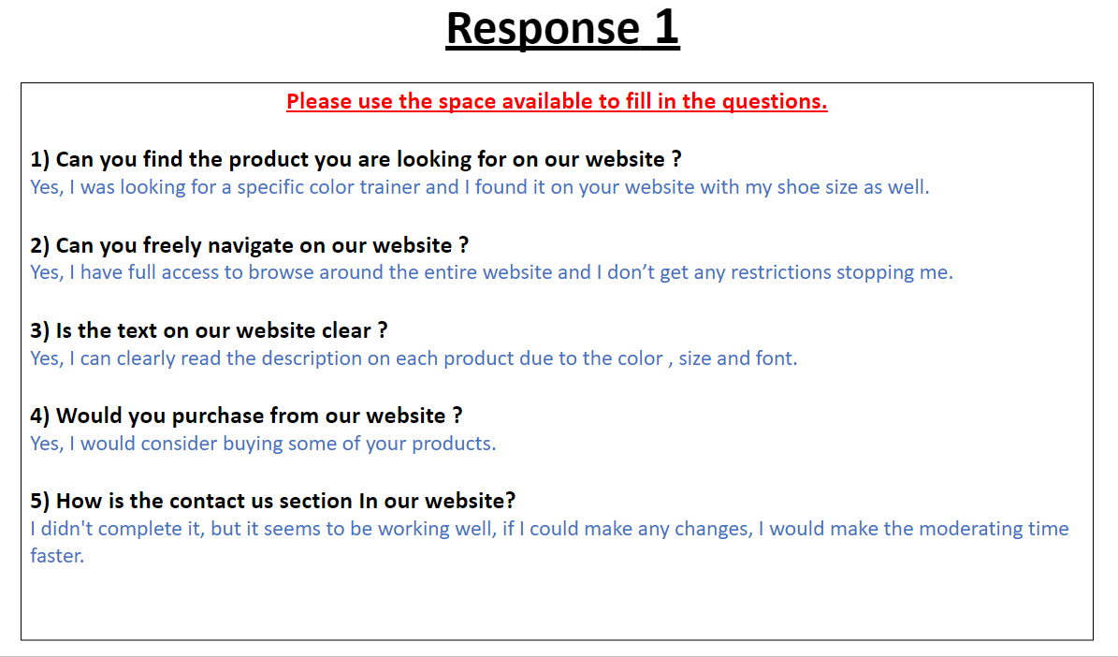

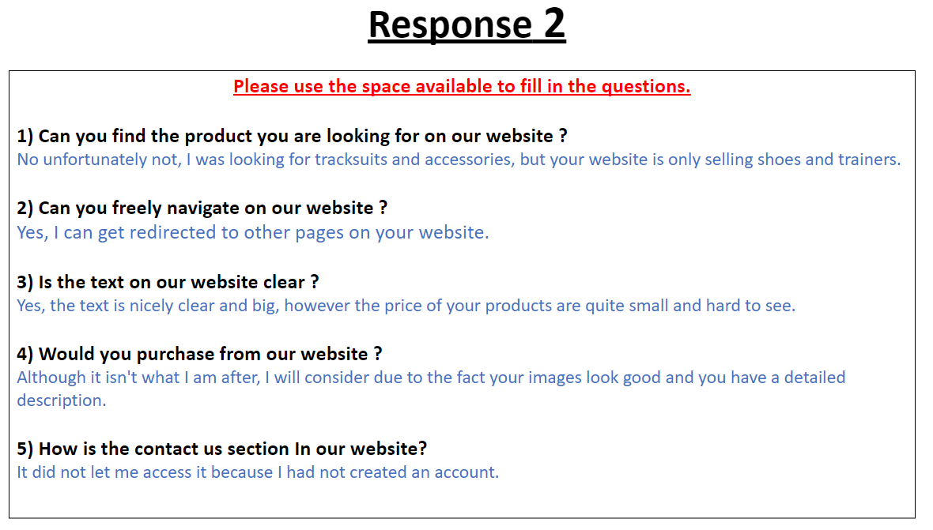

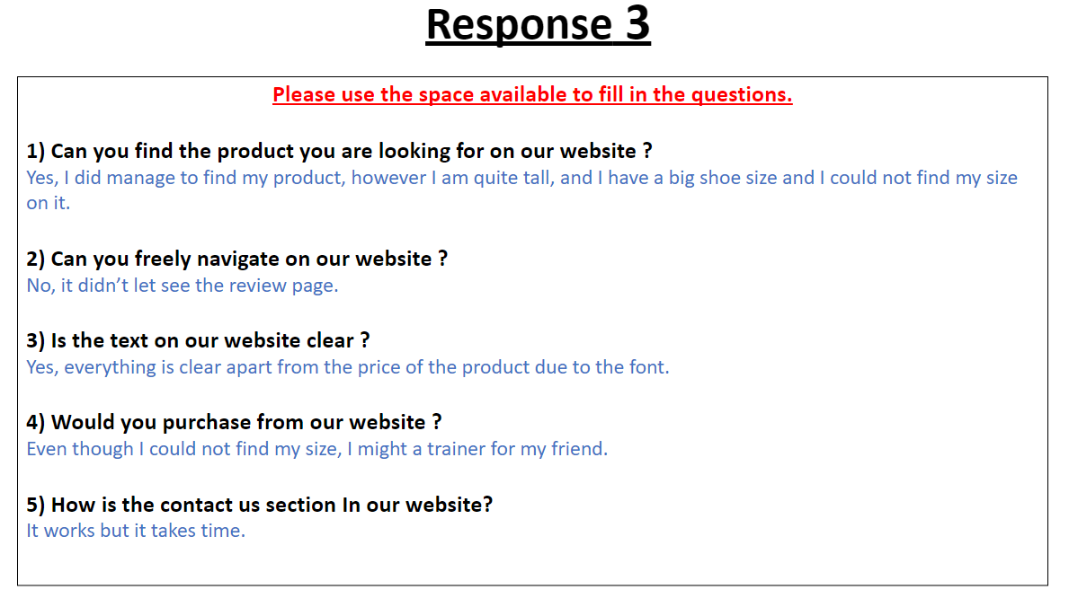

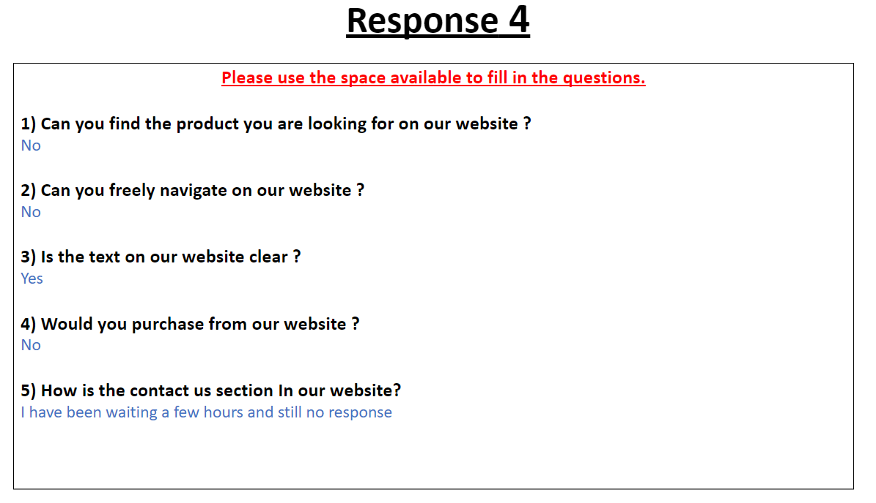

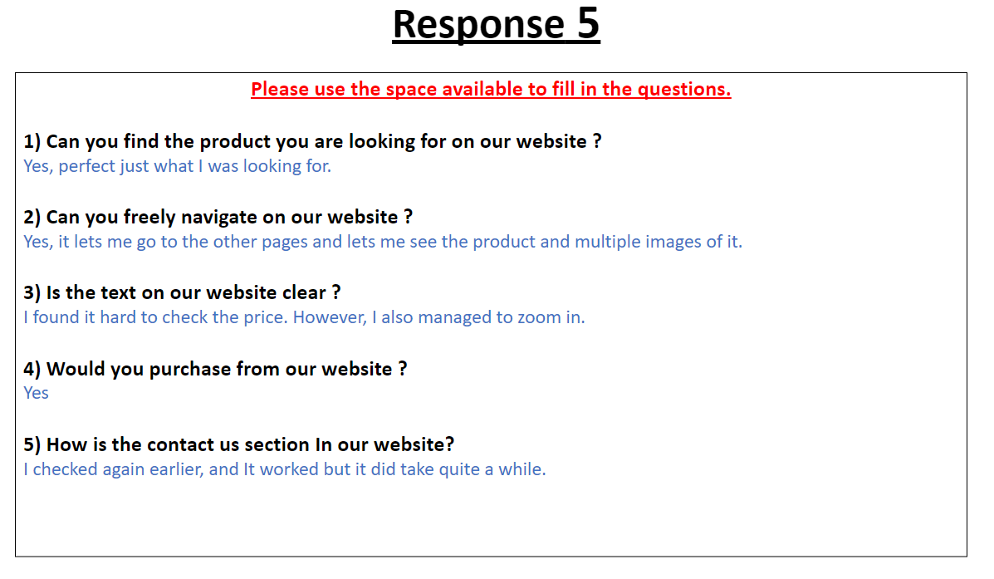

**Using feedback to make design changes:**

Looking back at all the statements, I will decide which areas need improvement and I will adapt to those with a lower rating. The ones with total disagreement will be improved and the others with low ratings will also be considered due to time limitations.

**Testing the website:**

Test plans are used to ensure that a website works as expected. In other words, test plans ensure that all parts of a website play nicely together. As this testing is often referred to as 'black box' testing, since it does not focus on the internal workings of the program, but on its functionality. Test data is developed prior to the website being built so that, once the site is built, the test data can be used to verify that all elements of the site operate correctly.

**Why is it important to get other people to test a website?**

For the designers of the website to produce ideas for the website, it is important to have other people test the site, since they might not have produced them otherwise.

**Testing plan for the website:**

Testers will be asked to test the results of a few features on the website, as well as a few other aspects of my plans for testing the website.

|  |  |  |  |
| --- | --- | --- | --- |
| Number of tests | Page | Expected result | Result |
| 1. Fonts | All | Size of text is appropriate and able to read. | All fonts are easy to read and clear. |
| 1. Links | All | Links should redirect to another page. | Links work and you can get from one page to another. |
| 1. form | Contact | User has access to type in the form. | There is a form which is editable. |
| 1. Products | product | Image, price, and description. | Product images are displayed with text and price. |
| 1. Logo | Home page | Logo appears in the corner. | My own logo is in the corner |

**Black box testing and white box testing:**

Software testing that uses black box testing involves the testing of software in a way in which the testers do not know how the application works on the inside. Testers using this method are blind to everything inside the software they are testing.

White box testing is a method of testing software that verifies inputs and outputs and improves design, usability, and security by testing the internal structure, design, and coding of the software.

**Technical and design constraints:**

The presence of constraints makes designing and developing a website more challenging. Depending on their nature, constraints can narrow or complicate the scope of your site. There are two types of constraints: technical and design ones. Some of them are discussed below.

**Technical constraints:**

If there are not any IT staff available with the skills to create a website, the required design and development work would have to be completed by training staff members. In addition, there may be full-time employees responsible for updating and managing the website's content, which is a technical constraint that needs to be considered.

To start designing and developing a website, the website may require specialized hardware or software.

**Design constraints:**

A website needs to be flexible to work on different platforms (both desktops and mobile devices), so you will need to take this constraint into account when developing the website.

The client may not be able to achieve their website requirements within the budget they have set. Clients have agreed on a budget, and it is your responsibility to stay within that budget. Even so, you can present the client with other options if they want features that are beyond the budget.

**Legal and ethical considerations:**

It is imperative that we consider legal and ethical factors when developing and designing websites. For instance, there are laws protecting intellectual property and those protecting a person's personal information.

**Copyright (Copyright, Designs and Patents Act 1998):**

Digital media, such as music, books, videos, software, games, and movies, are all covered under the Copyright Designs and Patents Act (1988). It is a statutory act that specifies what rights creators have in original works, such as photos and logos. The Act describes how you can make use of your work and how others may not use it without your permission.

**Data Protection Act:**

This act regulates how personal information is used by organizations and government entities. It was passed in 1988 as an Act of Parliament in the United Kingdom. DPA regulates how personal data about living people can be used and protects individuals. It also applies to computer data or paper records containing personal information.

**Principles of the DPA:**

* Transferring personal data outside the EEA without adequate protection is not recommended.
* Protect your data from hacking and loss by taking technical and organizational measures.
* Respect the rights of people who have provided you with their personal information.
* Data must not be kept any longer than necessary.
* Do not collect unnecessary personal information.
* Updating and ensuring the accuracy of personal data.
* You should only collect and process personal data for specific, legitimate purposes.
* Fair and lawful handling of personal data.

**Common Tools and techniques/features**

To meet the requirements of the clients, it is essential to assess different tools and techniques for development after an appropriate design has been approved and completed.

**Language for developing a website (HTML):**

In HTML, instructions are contained in tags. Every instruction is enclosed in a pair of open and closed tags. Pages should be marked up with *html> tags and */html> tags to declare the language of the page.

It forms the basis of every web page in the world, even if some are in languages other than HTML. HTML is very widely used, so much so that all others are almost extinct.

**HTML5:**

As HTML5 has been finalized by the World Wide Web Consortium (W3C), it has a wide range of technological features that allow for more interactive websites and more powerful applications.

As a web developer, you should always use HTML5 when developing your web pages. Today's hypertext markup language is the standard for structuring and presenting content on the internet.

**General Features of HTML:**

**Tables:**

while using HTML, tables start with <table> tag. When using websites, we rely on HTML tables to present content which are specific.

**Forms:**

in HTML we use forms to collect the user input. Below are the 5 areas which are compatible:

* Radio buttons
* Check boxes
* Text area
* Submit boxes
* Text Fields

**Navigation:**

Navigation is the approach to operating around a site page to observe what you want. From the start, the overall web was limited to just utilizing hyperlinks.

Navigation menus will seem anyplace among an online page; however, most web site developers tend to position them towards the highest of a webpage. rather than ancient hyperlinks, these menus are additional engaging and esthetically pleasing. Guests to a web site will click on a menu and it will send them to the page they are searching for. or else, generally once you hover over a menu, a sub-menu can seem.

**Interactive components:**

Interactive parts are used as a way of enhancing the design and feel of an internet site. However, an internet page should not be laid low with too several interactive parts because of they are going to increase the transfer time and may create an internet site look amateur Interactivity involves two-way communication between the user and therefore the laptop. In different words, it needs input from the user that provokes a response from the pc.

**Buttons:**

buttons are a component that the user will click on to open one thing, which is able to send them to a different page. They are little boxes or rectangles on an internet site which might have effects once users act with them.

**Hot Spots:**

Like a button, hotspots enable users to open one thing, which might send them to a different web site. However, like buttons, hot spots square measure typically giant square measure on a website that is usually invisible. This could be helpful for things like clicking on a picture to expand its size.

**Pop-ups:**

Pop ups are seen all the time on websites as a form of advertising. This is mostly a small square, sometimes even a rectangle which will appear on your page. This can be annoying to many of us however it is beneficial for the people who made it because it is advertising their business or company.

**Rollover Images:**

Website designers and website developers both could create rollovers. Just like the previous 3, rollovers are also spotted on websites. This is when an image is present, but it can also change once you place your mouse cursor on it.

**Examples of accessibility/features:**

* Text to speech = This is a feature which is amazingly simple and easy to use. You simply just speak, and it will convert the audio into text format.
* Zoom in feature = The use of this feature is extremely useful against small text and small images, since this feature can make an area of the webpage bigger.

**The World Wide Web Consortium (W3C**):

W3C is short for worldwide consortium. This is a body in website design. Most commonly, this is found in HTML. If we use W3C then it will produce for our website tools and guidelines to increase the accessibility of the website.

**Platform Compatibility:**

To check for platform compatibility, we need to run tests. We can do this by trying to access the website on multiple devices. If we do not have any then we can kindly ask our friends and family. It is best to try on more than one type of device. For example, try on a laptop and then compare that with a computer interface. Try with an iPhone and an android and compare one to another. We see a significant difference when we compare mobile devices with desktop computers. Due to the huge decrease in size from desktop to phone, it causes compression on the site which creates a new layout.

**Conclusion**

In this Task, I started off by writing an introduction about my website design. I also added website requirements and problems which I would need to keep in mind to create a successful website. My document also includes the benefits and constraints of a website design. This is helpful for me because I can now create a website and I will know what I need to add to it and what I need to avoid. In addition, I have also created my own sitemap, wireframes, moodboards and alternative ideas to help me with the creation of the website. This gives me an idea of how I want it to look. There may be a few changes, if so, I will write about them in my next task. Throughout this task, I have also made a flowchart for my website to show how it should work.

I have also mentioned and given multiple examples of quantitative and qualitative questioning and provided a review of each of the questionnaires Aswell as an overall review. I have also provided a testing table which shows some of the important tests which must be run to test my website's work.

During this task I have also explained and provided examples of legal & ethical considerations Aswell as technical & design constraints. In my work, I have also made notes of the commonly used features and I have given more than one example with evaluation.

Finally, I have included the following: Interactive components, accessibility features and platform compatibility.